1.73: a) Angle of first line is 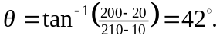 Angle of
second line is 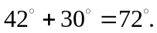 Therefore
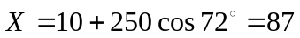
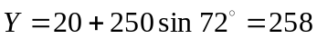

for a final point of (87,258).
b) The computer screen now looks something like this:

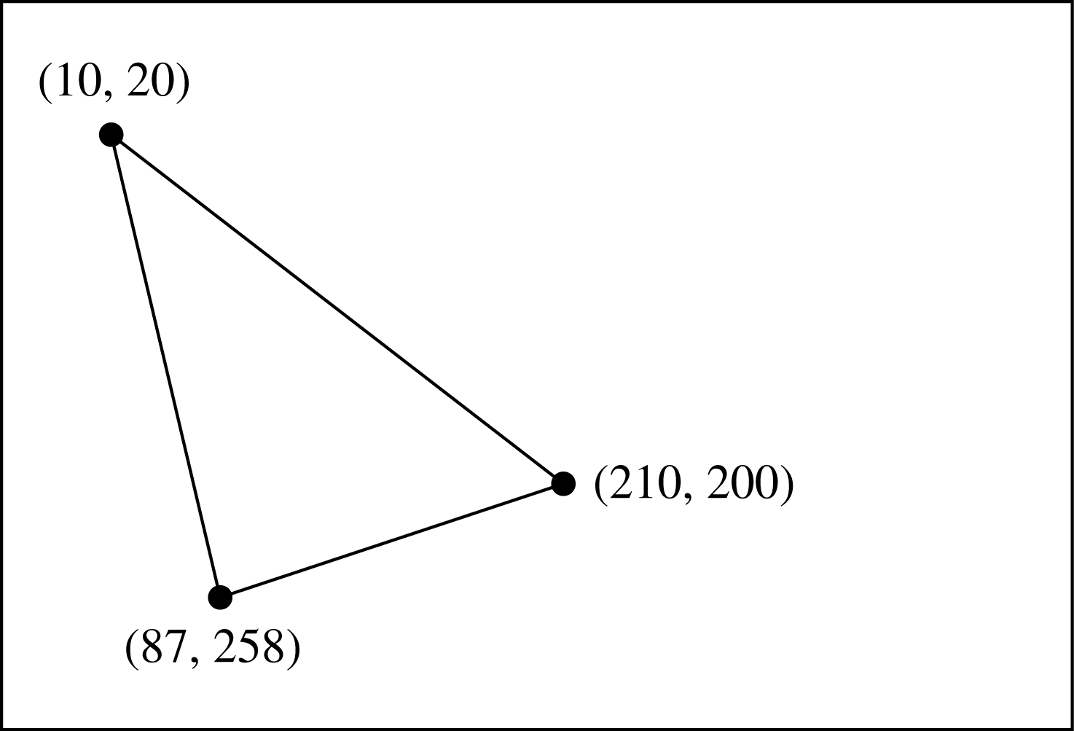

The length of the bottom line is 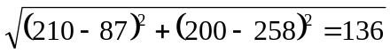 and its direction is
below straight left.

